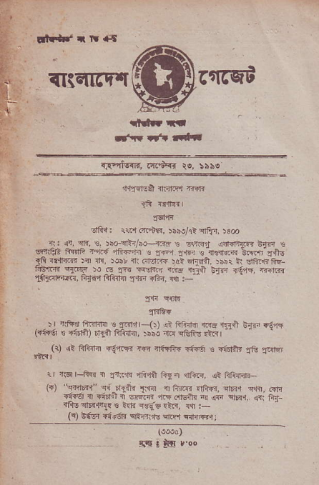
r!r+J r rr a{
fltctl4r|[ rqrq,B f
lldrrt
r^{ rt4| d.f
_{{F} ^{'rlE{?,} a{.'iqd te, lsae
nql?r:ial .t?tB 'r.fr
_{1R} lllri{ |
{@,13
:tfti: 1{'r arl i:.i, 5iioht eFJrr, )3e
_{ri:} ^{q4,} cl?, !, rraeTai/i.H.3T ! crsr i+{l1rr b;tfi t ^{q"fit} filtii ^{teE-rFir-,ri :} _{fir'J T.ri1 s {€i4.,ri} _OiF 'rfiE _{ali} ^{qnritT{} !d n!, )oir rt .rrrjrr{ rdl ^{Ernrlfr.} 5iir _{i} ^{lJlP..a.rfiq} _{fd!'m} ^{.)@} ro ^{h} _{fa} ^{-r-n- /i!} _{.3-r} ^{rrFi} _{<t} - ^{-':-) ,LiErffftG,} _{fuq41ifqFn} ^{'J.r4n} FEr, _{r{r :} "
_{. $1} qor.r
TiE+
) r rifte iiiifihr s 2|/.nlr _{i-())} ^{ji} fttdEr
("tu'r s +i6lit) rEn fiftiEr, _{)ib! 4nl} qGFE
_{€a{1)} !} Flnrt 41.ll'ri ryr ']trr? ?iFa s -.dnt
{ _{'t@l-fq.} ^{-f1ra +} + F!,1
_{tn)} ^{,.q,Ffrj o.} _{"1-} r.n { irtr ,,tr. w" e@ 6n o4i i' *i5rt d wir F \-!.h ' _{4f} e-r?r {: +l
{qE drirrl! ts ?.ri sr-iF.Lr, {{ r-
(c) ^{E{6r} _{"ir6?} ^{qliiri'l-} enF.r ed{Br ;
{o@6)
silt&loo
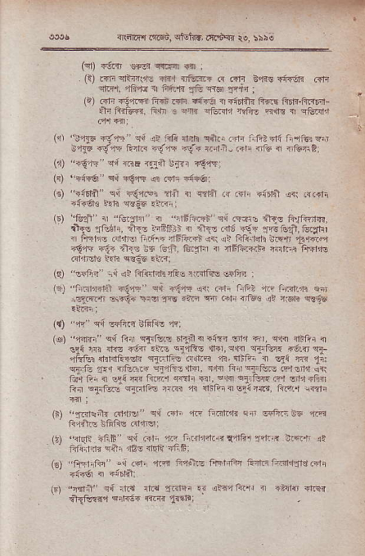
rRa&tt _{!'sb,} ^{qiot{r,} .rriujqr ro :5i{i
(sD rl5irr _{aaE?} ^{qll.dr} Fi ;
(t) _{i?lr} ^{qFitt'r-} d?r {trtu. ^{@ c{li E4d€} _{"f{'qs} rrli
_{3Lrl,} ^{-lfiqd} x i'ft.ri dt er6 sr.ir :
(i) rlr 6i'r.F. ffi @l1 aiTt { _{"ndtu} ftft$ ^{Ii6r?-Fi?r'n} ah Artu{r. ii{n 3 f,xr ^{qtun} _{ftFE} ^{qir.} _{i} qG.4r:1
_{(,11} ^{'il35} _{d'ri" cii !! arll r'.-E} ^{qilri} .nr i,fit4l{ fi'rib *n s46 {E-,JT Grr.i €.-,f€ Ek _{rc} ^{.i-} _{.?1i .tr5} ^{q} .trffiPi _{tr) "+!'ri} ^{' q{} nnE ii t !t{r rq"rl:
^{(s)} _{""io6"} ^{q,i} _{"€?r} {r r"1r ?i"6:
_{{!)} ^{"r:i[rn e,i} _{<'Jr'r zril {r} qrfii
?irnr. _{,-?h} ^{qsE€ ::.ji} :
_{(")} ^{'rsf} c a;:x. _{a} ⁻ _{l} ^{-?-ri s; ca. r} _{&e} F.frr, ^{iha',.feF".} _{"r:} ^{rt^.j} _{a} ^{-'a1} _{.a! d.j..:%} ^{ql} l4el., \f-t1d4-. ^{r;} " -b? ^{.i .r'r'".F,:Fr} Trr'" ^{aq,la} _{<r} .11€ t€ Gti1, tu5lir I _{l1i!l@ii!} ^{qnrFl} Fr?16r€ .stnt! t.h ssig .a.?;
^{''seE?'} _{iii 4t RfnFhrlio ririlFq} ^{qq.€i4} r
Gl
_{"irnr6rzFi} *=.r11' cl r!,rt rii .?T.r t1f?Z 4q f.sn.h e.t _{\s.c.rqrB} ^{qnq+ 1?q} _{!-E} '!F fr &n' rrts€ !! ^{q'} _{h} q€68
⁽⁹ _{""i!'} eri @fi.q strls ?c:
_{rar "r:rF} qr _{ii} ^{qffc'e} _{611.:} ' d'rJ ^{r"} " r. _{e@ nc-'} q als rr1 _{sl<.i 4{} ^{.il q'lrffc} d.r.e!rq e?,{@ rtfet f"fii _{dirda<dr} ^{q{:lF!} 64liri fi, {lifni a ^{qi} _{na} r11: _{e!.le.]r'dJ..} 4qi ^{4t3.ldr r?} _{1'f!.,} -J:-r"d: _{r+ t, d} ^{.q;} _{rr} ^{'l_} @, r''. ^{e} _{r €r} ^{'f,} .F !- tii--. 1.. oi.r..N _{{d} -. _{.4i} ⁴ 4'-E{€ei_fl. FF.r i4ni
_{{t)} ^{!,Tat!tu} _{.alaB} ^{q{ ,aii ' '} G,ir'rrE ifsFrc 4d'riv:
_{ItJ} ^{-{eN} nFF'qi _{ftri} ^{,r.c FririJftin} fllG.r Trtnn lrrra ^{1!} ' ' lif{.Jt? eii niSs rEli +F6: _{(s)} ^{.Frr'tfl"} _{", d'} ^{-{.'n} P,?in! f'r+nrfn Erir th.E|?.al'
^{(r)} _{"1'1i"} e,! im rl.{ E&lqi ^{?4 efi?frrlr 1} _{"Zrb} its. _{!a{l'n"} e.h;+ @, 115':
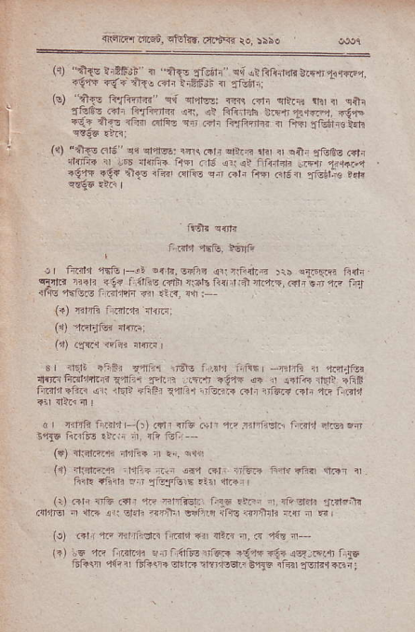
_{+cmr1ftF"',} ^{qMa!} ar.dFr ro. !\r!
^{{{) \+{E} _{a.?Gjb- 4} ^{qlrr} _{J-51} ^{cq} rrr.fr. tdh !rE41r"G/ ^{+ieq rf{irfr.r1r tiREJi {} :f=ijr.
^{(!)} _{?q"} ^{'?rF-T e{ m{8. Fq} _{,<1r} ^{ofr.d} ri ₄ iar _{aL3-, Fn, t.ftn} ^{.r.,} r- lsir hF _{1}44.rrn} riF {,:
⁽⁴ _{"Aw ni6', ei} ^{qld@:} rrr\ Frr aErq _{xrr 1} qlti ^{gfof-€ Gr4} nsf{r rr ir.r rr{rf-e E{i .16 {r:<l flirr?ri ^{!F]'} t.r{r..r _{"{?E} aqr.}r:o rGi 6f$a e.n Rtn F|t ci5 :fetl.@ r?F
_{ii€]l} q{tr4
r:d,t,r..-tu, n;lft
_{rt t'nl'l} ^{'r'fo} _{r-!i} ^{orfi,€nFi} {i: rFi,t& :r! ^{!i:Fq4i F{1n qqftr} rrrrr ^{<!" llhs.{ir} n6bir{xJ1rlrrF,r?1lil,-r@ trJ ri3s ahJtrs Fifi,t'dr Fi l:r.. d[--
^{(")} _{r|1ji ndE,lr} :rrj(i:
at) _{€ll.r} otii {!tF
_{r, Ielr} ^{/-<il} _{u.|1'. T'?} ^{_.4"} _{'.r".} ^{-,.,Jr ,.r} _{r"t."} ri irFrj ^{f@14'L3} € | ; _{:-:} . _{r-.i} .?"ln ^{r?} rd,l4 ,E. ;iE _{ililrt"ii.i} ^{q,r} rr'{p* ^{+n$r t,ilii.r} _{"iq?R} .rrr 1il6{{ .+|] rn iratt ?n {lt-r 4 r
rr rir"R Inirn F(t) .?rr iG arrrir rzFfr€rrr i1!,,1 a]G Ra -46 _{fi.it!} ,rir; ^{iir.} 4r? i,i,i
rtntft1? il,ta?4 n! 1!, c!i{l
^{;lintfrF rnrl:.} -rn 444 _{Rt'} ^{1ii64} F4r ?ftlj 1l?r
(1)
^{Fil: {.qlh} _{"ri Etu-ftuiE} ?i!r cL.tr
⁽¹⁾ Rrr _{?iJb} ^{("ir} *r Fifrelr ^{Frtr.tFn} _{"r,i?El.fi} rfl?,:!r _{.dlnq} ^{q} iir irr sl?ir _{4rrFi} ^{qofac} iFr5lq}li ;rs i E _{ir)} d _{r 14} ^{;rt.} fr I !r ^{dir} ". ' _{Jia} -.. ifrc {r'|'6fF ^{^ri-.rF4F} _{6r!?} r'r:83r.-.t
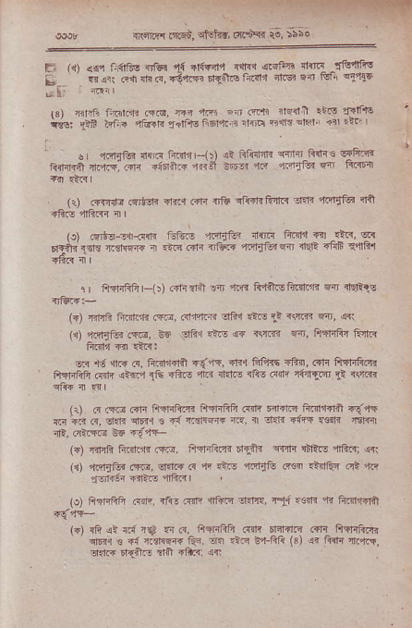
iriqli'{ aiiq,'. _{cFFr,t aiat<l to,} iboe
lii {n) 4fi f.i{ltF _{rrl6i} '!{ rif€|,l _{t{Fq} (.sftr 4{'r1 {&qiiru ! ^{* sr arr} _{"n} a, <€.'ttrr 6rF:'li! fin?ld clrB !r' _{tr,} qfllE
_{iar frri- r.4t1n} ^{rfil,} _{F-} rt' ^{,r} _{!?.?i} 1l-dr ^{trF} f.r{! ^{irio:} _{rii t"."} ^{aFE} _{l-ftu} rq..'tF.'.
! q-fi '{.tr iri- (r 1, ri,r--s! {fr htn ' 3r€.4 tmnl nnrp".- di6ilF 1 ;jr _{e6:.} ^{'tr 'ri"?} r ftqa
_{il)} .f{fir! r,-t.rr d4.1 cdr 4i6 _{alirllrtuF .lFR} 'l.it{G {in
rrr dir :!lra,{i' _{fi1} ^{'P'a=} ?@ ^{jif} q ⁺⁴ G _{6r+".'"} y*.. tftF _{tez} -.-r=q d?F a.5 r4i.
1L 6ffiF(]) .i-?ni 15t ?r* n4+-a",r.,n o" +eFr"
(?) rifiF tu,jtr ffi, .{rltlr?'r ali'r .n! t: ^{(ffi} si,, 4r (.r) rfitur cffi, ^{d{:} _{1tu r?.E} ^{q{} 3\'nr. f6, iFrntu l-rlri fi.eh m rtF:
@ ^{'16} {6 fl, ^{fitrlndi .q--.E,} _{"Jr{ fnf'F5 +fr4,} ^{(il'l} fiffi.rn
Fr,lr.iiE c{mq sn ?!i difffi.l fir.s ^{?fii d4r? ri'ia.4t} * \t{< qiR ^{:i} .q I
(r) .4.sii.$r fl-r]rftlr frErrRft.{fi Firir.q ii.'l"rdn €{q5 B id _{a, lidn} ^{qn?{} s _{d} 'r3Ffi{ ^{rF, rl .tin} _{"it,F} *4ln €1{n]
nP. nii.lt@ Rs i3 ?,.-
(+) rn6 ftar.jJ3 fe, ftrnft.'n rr{ft wh !nF.5 4fiar; lri (r) dxii? .!1E, _{clirq} ^{(q} +r _{ltF fii!fit cM .ndE4 .,ri} ,l1n ^{.,Ei€i} ritre 4ft3 |
(o) _{FrrlraFi dfi. ri?. .:nn!} ^{,llft_6} _{.F r, lttl .} ^{_r 'r{} fiElffill
(F) {fr <i i.{ r{t .{ r{, lt.rrRh rfir da{iF dlr Fw{k*i ^{qnnr} s .:l r.dq€ 1E?. !r. ltd i"FRri (a) !r Rlh ft'na, d.ll_r 6lr,ilG atfi +tur: <r:
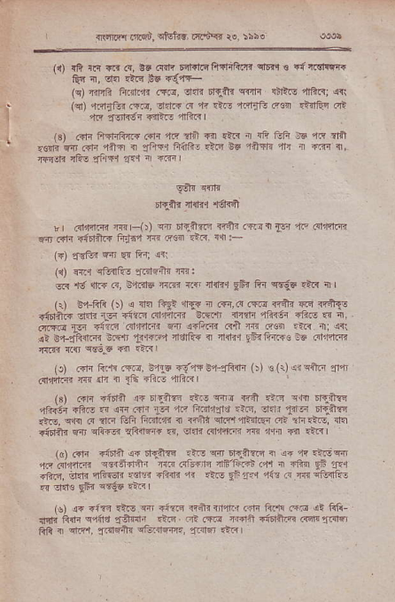
^{i} iRdr",r .'rw"5, snohu, Fr,iY. te, isso
^{({)} _{!F rq ?i?} ^{(q,} !d a{r t4r.tclt?rli,{t cnfi s ^{€fqr!1sR '} _{Qn ri, sr. {i!} ^{g!.} <1+- (q) _{nffi fi.il'Jr} (aia, _{d?r{ n.ttd} qqr.I ^{qiais} _{dFnj} qri (91) ^{q.fi1G.4} _{ftF,} ,3r.li? ({ 4t El- zdF.G dq .d&n crt _{"ttq} ^{zrsrrfdq {41tr} "l|ftrl
ls) rdn _{FrdrR:f.{} ("r{ ^{'tr} *fi {i .trr _{i cii f!-fi i6} ^{'lR} .1tt zdi {n.{h 4i')T { EFlf1 ffaR! .t4 d5 ti}qRt 1t I riTq {, 'flr{-fn rEE 1l|tr {{1nr {.n ]
_{gtlr} q{'fi
_{5r+-i1r tdnr} 'l€hn
rI r4n?i.{i r_rrrr-()) cn ^{6r..ift" rr{ir.rriri} _{IF} '1F ({ldqtfn {r'.ir +itfiL{ _{turfi} ^{rrn} ff€"] dtr. !'.I:-
^{(")} _{{€G]} r.n {{ e_r; !a
(.) _{?,Ir1} ^{qriirF!} _{fid-i"} m:
@ _{rd} ^{ql..{} _{@, &Lir6 uri R6} ^{'rtdi{} _{9ar fir} ^{qEgs} .lrr rl l (:) sr ftti (t . F fr:j ^{c-f"} " r c,.r.r 4"'c rF}{: _{"ifift?} ,-tr _{lsi} €fl _{Fffi 9Rf fF} ^{-@i} _{{€'.: fl} 4
er nttt * l*^,xq _{.{4} ^{rfl} _{oar .rc} ^{,t;} .<,
s! _{s4-!iid.,ri} ^{:ffi,i1} _{tl,lf:,} ^{ddEq n ftiil} _{?iFn1+4Fs} nE alsntcR {4in _{ff} ^{qv-!]'} r?l ?aRr
^{(r)} .dr Flr! _{<@, erlq i-!,r? E4{Rfi} ⁽⁾⁾ _{ts (i)} ^{qi qlftr} lrir rdrirr_|{ m <fi ^{i} ₁₆ inc nrft3
^{(s)} ."n {fdn _{!" rrniq} ^{pt.6} _{flrr r'ri EIF} ^{q.m} t].-fr@ nF.qk{ +Fris _{F {[.r <fi} ^{'Fr a? F@1jrds .tG, !Lh} _{trl]r} 5l{-ii3i _{drE,} ^{q{{} .r ur6ltfi fii4r.i? n rril elii'r4ldiEr fit.r{.l.$, r|1. {i6ri}4 _{{n} qf€g ^{qFiffi} _{a, ddn dn'ri.in i.r:I} ^{,|.lr} Ti .i.1
_{lsr FF} 'itr"l 44 r6iE := ^{?T} _{ryi_r} n 1 ? 'rE4 ^{,ftl} _{cr1zrn q€a+d,iri} ^{-rtr} _{dl.1a 1lt'=-n !} }l ,r rio ^{q5} r14 diE, fr{.ffiFsn.$.i _{ifr.} ^{,-1i !t-} _{9FF.1} 1tu ir.fn efuie. _{!r !J.t€} gfir {€'s! a'ir I
(s) ^{r"} _{"i=_4.L!} m rtlxc ^{rnilirnlrr cfi Rr4q Fa {i ffi} fiti _{Rnl} ^{qq{l?} {€l{ali ric4 flt .{d 8"lfl dEltlrB Kd]n$1r6r ftq { si!.r, lrdqatr ^{c&ffi4r.,} {dqr itr I
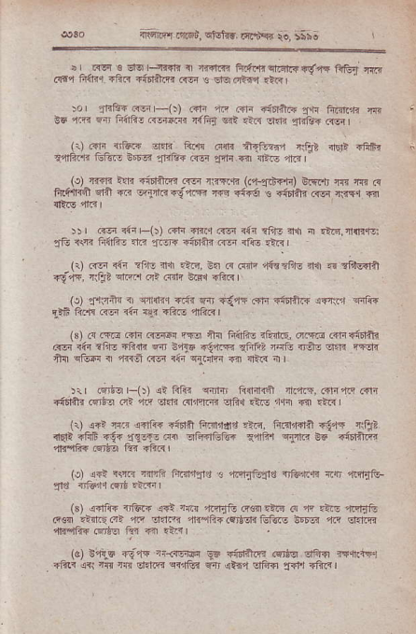
fiarir4.rfl6"!, drhr ar.u'ci ro, $;a
.. _{I 6F 6} ^{-fr} r..ftR _{r} ^{.rd.n} _{?-"c'rdr'.c*} ^{'iiT "r,} ff6r frft{r ?FR ?i6ri.rr .{rr € Er.rcG{? ,ta,
^{.L' -4"} rr-i:j _{r+} '- lff ^{diF?} _{f.r} ^{Fi'nj} T,l 96 ra Fr Fitr4r Frhtr1 F+p @! ^{:t-'r :-} _{FrE+} (E,
(r) ft|i rrtuR d?R ft,F dfi {rFi!r.r riejt nEp {hFr _{?4Fili.<} ^{Gtu! 06v4} lfrtur F€r !rf{ {i {li.G 4rr r- _{{rr} rrq tm _{€irrftd (E} ^{pE.fi} (-{rtr{F) 6rFF ^{m m} .4 tuf{q ra _{n} ^{.-hFtr.1;.-} d 4?6 . {infli lo rqq s _{ll?.E} 'n.|
5rr G_fi sar F(!) .4r_i d_<1 rcr ?4r !fi! rM { .i3, a{rnqe: ^{JB} " T. fr4F- .? _{f,.-} ;ir*. ffi {fr: ,r3
(i) R-r *r zft- irt {?n, _{e.} ⁽¹ mrq fR?fir- ?i{ h lfd!?nft _{d?r,} liax? eric?r ct ..!1r WE. +ftRr
^{(o)} _{4,Jr:Iitr ri} ^{q|{ij1} 4.ir _{{n rd4+ eir ?idrfiR i"n.r} {flfii i_t6 frrr! r<ir r1,r &-i +ft! lGrsl
(3) _{ir.,rG} ^{(.lr} {i!@ rFi ia FftFn rEriip, d.qia 6Fa{5gti n 1id 1'.1?fida 6 ^{rT} _{"i,@} qfrz r.4. _{r-.} * -F- _{+{} ^{qfF} { tnl .{i i+' T1(drrr _{{i} ^{qir} i
_{:ir 6iqr-tt {! Rf{r} ^{qfffi} _{R11-1cf fl.L{,} (qn,n? (?Tr _{"initr} csrtrll ^{.It} _{"r.' ?a?} ({r'nl.]n cifi{.L! 1f,r1 ?{r .i.{ r {1) a"i rr.r 44ii? riDlft F..rd4! ?na. fi.fidn ?64a ctrr? _{{Er'} ; ^{rfr} _{"i!} :,€-"t: _{F!} ^{-ri4rir6n} _{i''} ^{e?E} ₉₆₋ ai6r.'"E 4rqk{ r}a lli .lic
^{,r} _{r+;} i.F '.* ^{_r;41-tq} _{:.4-prtd.} ^{iftrl.' itF} rcEri!-
_{G,} a'fd {-@ ^{4d} _{"4 rq<i} ^{(@.*F} _{c} d ^{.n-,} €lir': _{e€s} rirr c' Rp !7,{ _{ir- F+ .{,t m lf.tu b6ri n"} q.m 4rilfi{ 6l'Er afi ?n .ta I
(aJ _{9q-6 di'r+} ^{ri<{trF} _{eE} d"6r+fi _{@6o:-T{} a.tl'. _{Tt? d:} ^{-fl 'fl} _{d.r4} ^{qr1tu F4r 1t} " ^{<fn} _{"f"l'} <rr I
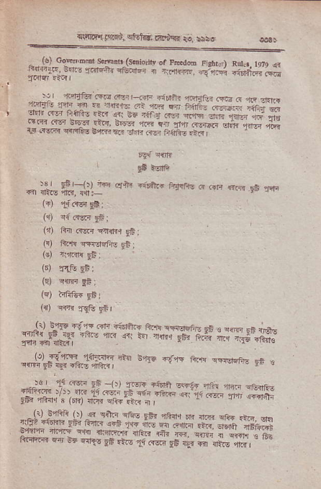
^{.r'.n6a} _{!!Ea.} ^{qf!18} trr'iEq ie,
₋ r_t coE mdr ^{s.e ({dio.,N} _{or} ^{prd6} Fstu.) ^{Rtrl.r,ldr,} f ^{!rn:@ 14,} _{xire+.} ^{qrrEirF.} . _{ra,1@.} ^{j.jF 4+n**} _{ir1r{r} iaR I _{_),} n'rtB ^{ffi} +.r, ^{,=n . o"} _{"*o} ^{itrrj1.} fln _{.. n} ^{,1{a{e} _{4i} ^{.@ ET f,d+ ---} di; ^{;..,r,,'n} _{;, ;; ;r; ; *i;';*::''6j} * dF .B !6'n ^{itr} _{]-;-*;.;;" -;; Jr} ^{'- "f€} 1"..;;';;d;+# l.
691i c{T 4
_{3fi} rrrfr
,!, _{.D,-rJr} hn _{crb d6n!+} ^{_"rq-d! p,+? fF} _{fn-} ^{"Eri lr{r llttE} _{"i1!?,} {{r;
(?) e!'rrvq '6
(r) lix _{.{Ed} ^{qr{i.r} !ff;
(!) ^{ftfi e{rnrffo} 9b;
(B) ^{rgrfi{} EE:
^{(d} a(r:6;
(q) ^{lrfir@} 9fi1
_{#Lfff} ^{6#"ffi} LnkwRs+lrH.ffi _{,#)rflg*iffi*} so's i!-,q ft"lr ^{e.,"'q'-} e6 !
,-!d _{1c} ^{ir-rr} ₉₆ ^{_(t) T6+ .Arrr.n} t:r ,ri _{"rrn)} ^{ji} @r _{rf;} ^{q6n} tf..m _{?E?} rftir.r 3 ^{(6r.)} iar ^{rr€'erR} i ,
s(<?_?i1ii ,nEli qtu{Fa ^{cr|} _{1t} ^{c-r} fi $anlr
_{Rr?@} #ff#T:kq$#rr,tr+## h 3j ^{dqa! gt,ir,} _{1.} ^{err"} _{9f} +-r < od, m,
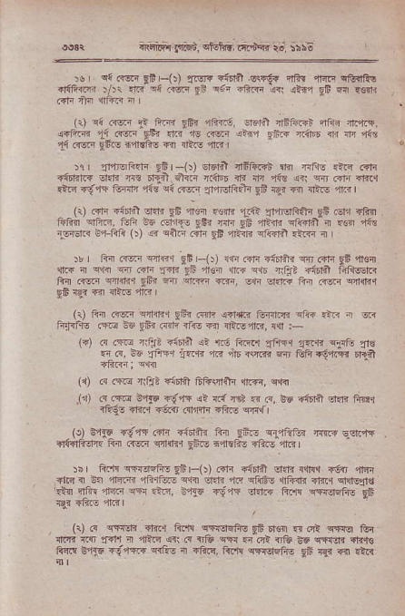
d!ri,'cr:Fi6"', cioftir, .r-,'d iii irto
.! ^{o{ t?5r'} _{E3} ^{-rt} _{$si} r6'a .s.d6? 'rq -F.' q?{n€ d"4€ )l)' _{w} ^{q6 -ji} _{tn} it" ^{-fi-r} i{. ^{rt"'} ₉₆ @ r€dr
_{(tl} ^{qd.ff} ? ^{tu} _{-w} *.. ^{--'nnrE' -"r} r-"1*. ^{a6t'n} ₁₄ (n gft _{n} ^{.-} _{cat} ^{j>n} _{,-liF} ^{,.f6r} _{o/ 4} q ₁₄ ^{.{sir} _{9S.!} il|dfrs fn 4l_is lln r
^{)q r} _{lr-r-{'F tt} ^{-(t} *"r 'l6E 'i rfr ^{ilq} _{"F} .ri ?t6rre ^{rE} _{"e} r<' _{A@} ^{_dtb} n +n ai€ .+ ^{w,} crr dr.{ rtn i{1e _{ftm"r ?fo} ^{qi 6_sr.r} _{fl"rrdRfF EA} BJ {{J {trs d.r I
_{i)]} - -*r ,* 6 _{",|-} ^{,q} _{tra irri.nn Ei.r-} 6ls{ trff !-4., _{%.' ia 615:6?} ^{q} ₁₆ qtri ^{qehl .} _{rr} zr€ ^{'rffi} :+FF l)) ? ^{e"@ ?F} _{Ei ats} ^{r@ri} *rf {,
)r i fti .rer ct€1 gF ^{-(:) {{r R|r} _{"tdifr} ^{qfi ."r{} _{9fi} 4rs{
^{'d..} _{rj} ^{qqn} n rn fdr _{F6,nsa 1rr} ^{qib} rtJt itunl ldlwfi _{tir} ^{(i@n} fll{r{.r gFr n ?r@ ^{lm,} E{q Er{i.? ln .i!fi sri{tr{ _{9F} re"? -ir 1]ai€ 4.n
_{G)} ^{R:[ .r-srr eifi.r} _{96r} ft'r? $fiPn tufidi ef@ :iii i 6ir ftIrf.rE 4rrd ^{!G} _{t6*} .ffs rr€ @ rt.tllin, r{l :-
(r) _{.{.m} ^{q*ac} _{-iffil} ^{qt} 1tn FF.'r fr.r.r _{1l!!{.} ^{q1{G} zns .i.r, ^{Bo} rilzrt _{iR.fi 4."} ^{,i,6} <(r.Tr ff liFr{r.{r n+g
({) d .@ {lirt Fi6rtt _{6jisrilr {r.r,} qfi
_{.\ rl} (q ^{(@} !"F di'F lt rri @ ' ^{({,} 5. c'f6n \* r.i61 rfqr Frff {ftm _{.{firr +to.} qflli
(el 3d.9 ^{6t'ia} .iF srtr>lr ^{fr.} _{tii,} af iff.i ffi ,-ard d6+i?rrr _{fti} ^{(iF {ifil} _{rft-} i'n AE _{+ftr} ,ir{
_{Dr} Er€ ^{qFf,iEFri} _{t5r} (t r@ {td eEa cdF4 ^{'4.} rtT{ _{+l.q { t4} q?.a ^{z?} ?, @ _{r?} ^{.F} _{dr1, d.<h @.} oFr4d ,.?q qJFF ^{'f-d} ffr .tE, V416 {i,ir ffir+ _{ft'F} ^{q'r:rds6E} ES
(1r .! ^{qFrrr.} _{ra" 6t{} ^{dffrEF!} _{ri} Er€.r 4 6t s'ii tr ft'R 4d _{"r.l'r} :t ^{?ft?} fi. .! _{r&} ^{qE F} ct a€ E6 _{c6rx"} qrlts frcli E lXg i{'lqR crLs 4 .ftE, _{frili} ^{qrrersfr€} gF rW ri {ir
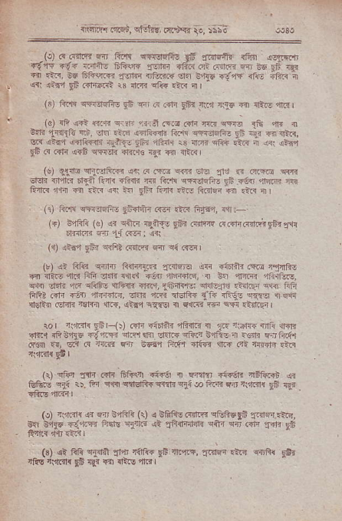
_{ntqror{ iffii,} ^{qteh-.} nt'ARr re, :;;;
(.) a.firr" r _{Fr!} ^{qqEFt} 95 _{"{Ir_Eft fit} jffi rgF +t' a"1-i1 _{tdF} ^{*1'} +ln ^{on a r--} "., ^{9c} _{F} r{a c{ ri.r..95 ^{tf'l,@} _{"-:r} {rFF @ ^{('lts} !t"r df!-? ;FF:t ^{!q rli,} _{Eb.inftdi} :3 _{rtcn 9i@} ^{.tR} i I
(x) _{fit!!} ^{qrr.1qfts} _{Eh} ^{qr il .dr EFr} _{:t.d} 4{6 €r {lirc 4iir I (d) {F ^{q€} €aE er?F 'rrn ^{ca.o.dFr m cflo} _{1r4} lir { ^{9.R} _{1ri{rn} h:, af. t.n a?GFi1i to"h ?rF{.Eifr! giE {gr @ 1|nF, cra _{.l_6"i} ^{q} <6rl ^{a-ii-:} _{i-. llFi} ^{:3} ]@ et@ _{.F} ^{r} _{,i.} jrE? pF tr cfir {rF c?f]li +ftcs aJ € ^{qt?3} r
(!) q{il! ^{q'r.qfti{} {rl _{.'r.ftii} ^{q{rr Ei,} _{!r! a .r.ria} q<rr _{lEfr} ^{r1rr} _{nf-?} ^{r,.-} {:@ _{F Ffl!} ^{aFrFi-:} !: ^{!4} _{ffi} : _{?'lr?} ^ F <r' r.Ti r{ ^{r} _{Fi"} ?a a: RoEr fi it r I (t 6.$ ^{fl'l.r'liliE} _{rMfr'r} ^{(1!r} rn" fi?an, rtri:-
(+) tr& (r) ^{<tr} _{_cfrn} ^{qft€} _{96?} ^{(llllrq} @l<friqiFpbi'r'4 bffi.lr fit .-1 i{gl _{i} qli
^{l{) iii"t} _{tF} ^{a{5?} _{orFl} d+ ,(.rii
_{t,r r, mF {nr''} ^{?qfn3} _{flire- r <sR} .F} ,TF: ?r _{ra-} ^{qr{} iifi if af{{ ; _{T-} ^{-1.-r} 'n, ^{€F'n} _{lnr]r 4.{} ^{qlist} {fin ?ff..r,lii_rlt1l: chle1't .arlrF c"rq finr filE?.{ir _{{6{l dfidri, eFli} ^{'fin i]E|ft{} _{Ii?} rtreJs eq.?s r|q$r d€lir1 _{4.JrJn} tsl{4 !11?F, ^{qi'l} e{?q { c{ani rjl car €{t5{ t
ro I ^{r9.i1!} _{9Fr-{t .dn Fi6rli{ nfi{.{ {} ^{.,tF} ri _{F[ <liir} ,ll+1_. 6'?.c {ft b1b 4i4F <+ ^{q{} _{e-ia} e_Rn }44?( r : €m ! n rr ry€{t Fs, ei< d ^{1@ 6} ;55- aF- _{fiid} ^{'.t?} al rTtr+n.nr
11) cfia :Fn _{.{]r Ffisti rffi {} ^{q{aru} _{?tuE} qbfir{i Glils e,i( _{1). fir} .i"niqidR-rqrElI ^{ql{} @ ftri Er.n ^{rrm_fi} 9E
(!l ?tn{ 4i 4 E4t'{ (1) 5 _{}trrr} ^{(i{F etueEri} "rq4.,i'c, qr }jF 4i"L.1 _{FFra} ^{ulnri 4r} _{"r€1fd'l?h} cni {rr r?F ^{"JE} tE
_{G)} .qi _{A1i} ^{q.Fdt} 1|r'r r-dr€ gF rl.{F,1ri!rd{.!rE ^{q{tF!} gAr ^{rFs ti,Ld{} _{9s} qi {o dt.E nlrr I
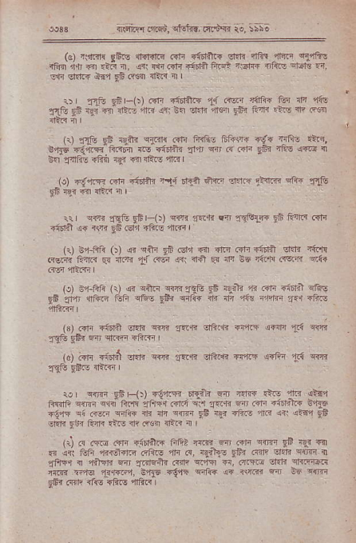
(o, ^{t:tF{} _{ift!} qtdtdt a c{F 6n6'ir.. _{eti} -'4 '1T!-, rl.ji! {Fq in rrr .r(. _{r} ^{({} tq _{6tr Fdfn} ^{4-6i} 4 tlF {rdtu eff_? F cfr ^{eJ.ri" &5.r} _{EE ..req} ^{qilri} il r
r) ?ntu Flir-r)r c4 @rFR 1r GEr? t{'@ tur _{4_} 'li(, ^{.1\} _{-F 3_?-l"'e;rF} 4{ ^{9n Er;r'i} _{9?} 6-a .t! 4' 4q
(r, :ds _{Fi rEin} ^{qTqt c{n irdo 6r?+ {E{} _{Tlc}} .r.?, ^{0-!r} _{"q"c} ?rri {tE drr'lr _{"14} ^{q @ .fl} _{tir t'.!} ^{j@} n ^{R.} _{TnFs} ?ftq igr € !ft! 4r- |
(!) ig,nn ^{@ri} _{"66rni} tn4 6l'f.ir ^{6rin lE1R} _{Siarir} qft{ _{F6} qr fl {i.r nr I
!-tG
_{ri} ^{qq{} rstu _{EEr It} ^{q".} rRf, en ^{r'drrfn} _{.E} tqlr dr ri6r.1 .. ^{{(r} _{rfi} .E|1 {fts md /
r{j !r fi.{ rr) n cil'4 eB .?1 f' ffi R- aiDrl sar' }im ecr itr ^{a iat} _{1:} <h * ri q d _{Ee} 'cn (.c: 4t{
rr _{t} ^{rd} _{r1r} / ^{,ft' via'} _{rdi $} r!.lr - ^{(+l} €.F' :t6E _{?E $1} ^{dtr-.F} _{'-} ^{,'bo} _{?6a} ^{rq@} d. _{nr} zra _{Dtu} ' a5-
_{G)} er' ?i!JA !ld? liB . _{fqtu EF{} ^{@ e'r"F} "Rrrr ^{(a)} i"ll {.1d;i €tfi {i'fl
_{aI'.r'r efi*r{ wfft} ^{qsrtr} _{1i} qrn a.?r.r" _{eiliti? wt"f !sft_{} ^{'{ii} qtr
rer iffi :fi {)r fi1rp 6r€lr @ @ ,fi. 1n tr!f. _{Flr} ^{qc.} _{"dF!.'j f} ir _{r@} ^{q_-} _{Ta.?} ^{n} _{.{F} ^{'rFr'i@} s% _{d.ri} gbi fiqtr .t€ rfi .rts4r {riR i r
ri @ c@ ."= _{a'FlE i} b, '86 r ₍₋ ^{q|m} _{rn} ^{!,-'} € m in tr ^{a.;aL1..e a- d, a"{"r r} ?Er
_{{459 i} 'ri}'d{ ^{y4t} :|.nlcnr4.rdr c.fi €, drriq _{E.F} qh.rcn .@ _{:Frr} ^{.F.r-d.} _{9*16 E(,r.} *@ -. dlcF ^{F} _{te} nr _{sdr dr, d. , {tuc} 'i]:A@
rr cE a{v.r { c{ hw" Ef { r{. _{.!si} ^{q+a.} _{t?{} ^{'9r} !n ^{q@} _{r$} id-r !:4 _{d;.!} ^{-rr e+d .'in} _{ry]tj r'E} cdaai,t @ @fr
,' | ^{*4} _{!&i-(.J} ^{gh} rrsri(4 ^{@ sfu -j'?} sB .{t tfr ^{\tv@} _{ri} ?(F{ dr.@ /r"?-. 4 6Fr< .r! ^{sotu ffiE$} _{:6} ^{,inri} I
^{(r)."1r} _{"{'|i}? .l"riit} ^{q,l} lim.{.tt ^{mF+} _{9F} ftr ?i3 i _{?FiJr n Gn ditrftT} ^{q'i?r} i fi6li aril
_{td€} rFiE AAq _{?Fil?} ^{(?t4} T.ll'F ra?" T r
_{G)} ^{meE} 9E 3fsr _{44Ti} ^{qvfic n'fifrq} rF
dnfi r\rR r{E lF.r]?.tRr .i'n riira b rcffi r:.r ram en?.. dJiP FlT llnir
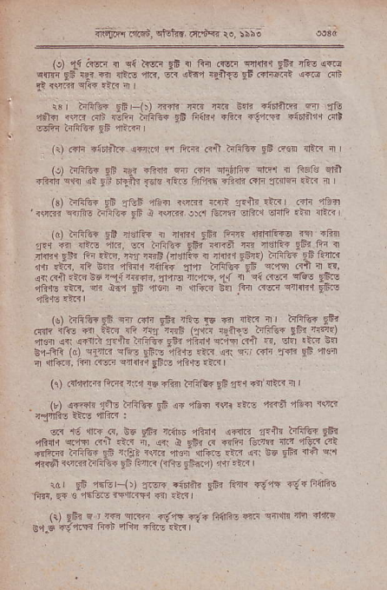
r., drtr. _{9s} ^{_4-} ₁ ^{'1171 gbz} _{"-t:{rrii,€} rn' ,to1 ^{']?e} 6 ci-N rtr, ^{s- n/F} _{F",} ?4rt @ ^{r{;F} _{96?} - { ^{fer} _{-Fl} ^{i.} '8. ^{sri 4{Jf} _{r?-1t1r} 44'1gE-, ffin.^.FrR ^{,r[} dF, cF E 1ftr.r tric rrf I'Fr'G _{{i} ^{q'ff} _{.rn} ⁻ -, _{4{:..i} es _{}61?} ^{aen.} f 3 ^{rf,} _{t} ^{d q6} _{@er} ^{qfE,} 961! e41B 'r3, eF ia"i _{gi} ^{,r€i} a f4 !. _{.?i @@} ^{frf} frre
⁽ _{r} '!, ^{"e E"} _{"n} ^{itr} _{?tr} rf, i _{F} @ .;rr t ^{ftr} ti- @l1 if{, ?" li- _{{4 f{r} ^{8:I{E} _{,",{o} ^{r,/t: tir6t} _{lf} \4) _{"re} r.. ^{.dri} _{[+} ^{Fdd} _{etr r"d.} ^{q;q.{.}} n _{ttr} ,i?_] 3fl _{b+ffi} (c) ^{efn" etr3} _{sF.s} r,i{- _{:ir} ^{q?i} e_.j; ^{cdr} T{1r _{9li} rrefl a $Fr!B, t{r F5E edfiq gfirc ?6.N- ctr I
_{{1)} c'lirtn fiiE ^{txn} _{_!E} Tlii ^{frf:'f!'} 96 ?"r d' rh'.r !' I _{{! J} ^{.'4} _{t:}} , ^{Ha{} _{ti} qir!: t{4 r$r"
3. _{rfie} ^{.6ft6} zfnrq 1ftr zrft ffi? rfii
aft". aqq n.l _{5..} ^{i,} $. t .trq o €iF7'qR ^{aa} _{"'tz} aB _{"rli."i} ^{ffitur} _{FE} rr-flt rst _{i nicri} ^{-ijF{rE ?ir {rr E@} _{FEt fia} q$
^{rlTft1rq,.{.t-:3} _{"t} tur." c,l,,r-i , t4:r."
r' gfi ^{5',r r), ".F ri6ft} _{IE} ^{ee r' 4t} 1+Faab ftfl, _{!-{} 3 1ert. <a [.{F{ fi] tr3 l
_{r.) ri? r} ^{'r<.n?fr} re'E ri" ei*e @ ^{qF*n} 't. <r€ _{8a.6,} {tlrF _{ffi} ^{,1Gs} -ftr a-ra I
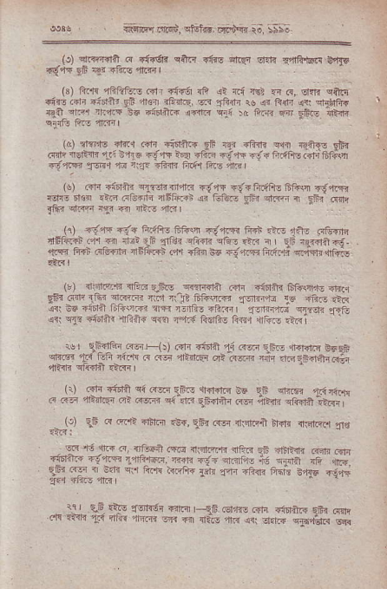
rtu! 6iLE!s. ElE .r r4'ie ro. :5t
_{(r'} ^{qrlaad} _{@ ri-6n} ^{qn6} €€ eliF ltrr rrJtuGra b.4E ^{-/..r{} _{Fi} rlr 6+rc .r.€ '
_{{s,} ^{_a.F} ,ffi;1's 6 ffi {i- _{f} ^{rJ 'a?} _{4 4,} qrn eilir oi.i.fr ^{6irai} _{9i} rnr ilrre s-" "riin _{ru ,i} ^{.tsF} !+ dE aF 1?n-.:- rrr 3d _{86ft? iffi} q,tr ^{.o} +i.? ^{d} '?\ ien
^{r.1. 'iFnta} _{fe} i4i 4+dl" _{w4} ^{q++e} t?{
_{@F} ? _{5't{3} ^{r.'} i _{i} ^{r0} _{e} -tF t6. .-- d+ _{'i,} ^{.fr4f,} !F 5t;\rl +-i'rM _{1Errr "re} t.f -fiiri tu1f(s fil
1j,or, +anu qzonqna oqft +{?F.ffi. tran {€fi- Er€i .16 icl,e{llr {itt@R ar eL.E gfi ^{er.rr.l 4} _{Eft} "Q,r{r @tr _{{a} aaPr,r a i,1.1a
_{r.r} 'tu'"F 67. rn ^{a+! F.a} _{iaE} ^{'Bt} ,r:, ir: @ts6ln _{rFr]tr3i.r'} q ^{rri} _{{lui} ,t'.{ ,:]- ^{q"r} _{"-."} ^{n.} _{?n} ^{r{Flit?i} _{rqi ftrr otdF} ^{d5torr} .a {ra 5.d . _{i} r- FRi ei{h s4, .ltr I
(r) lriariffs rJEF q.f,.s Rr.I{iir _{..fi} ^{qlritF} ffi\ltr€ {ftq _{?5"} ^{.4c} " ir _{{F.E} Fd ^{r_re 6id4n} _{rh5 1s ar,} *:R F. id _{+iEF'. r'+rd} ^{qn} _{l:r'n} ^{'!r, I} _{I1F<i t1z-:t} --d! _{{ri} ^{qT{} _{a,'Jflq fii{"ie} ^{q{e} --ar{ ti€fis fi€.r rRr .t !
^{*r} _{tffiF @r} ^{'rr} _{c.rl} 6r6e ^{?.a d.:r} _{lFn} ^{q?rlc} €se$ _{et} ^{-rr} _{Ta} ^{_:-} _{$e!} ^{(!} @/ f-4.R?." _{6n} ^{I'} c16qaic"i
_{r.)} l?lr _{6r6t'l} ^{q 6zn} _{!n-.ldt.lrr} e ']i ^{4ir€? 1.i,irr} _{@F} qrtr ^{->} _{carlf} ^{q, ,%} _{a,t rr'} ^{4F} i}n _{efilrn} _'rfll ^{rrr} _{36 @ r.'} ^{qiF} _{"+, ii-r F}.,} ^{..qrEt ne {.aLer{} "f€ @ , t @ @ {+Fn ^{G.r {.-r'r'F} {l1r rJ ^{4lrFr.} .4 .rE
_{+rnrl6} ^{.:-} _{fr} ^{--drq'l, dc} +, + rynr i. F{fl rfi tu fg A'iT _{" t'F} ^{'?tr1{} rt4 _{r-'} {ri'i ^{'+} ".:" {r;
_{- :l-} lE +s _{l'1!r} -R-{ | qi r'?2.T.i .Gt" gfi @,p ^{({ r}zP} _{1.i} ^{'na} 1.r@ rr< ₆₄ ^{qi-} _{F"} ^{jd.} _{,lF} ^{fj{jad.r} sE-{
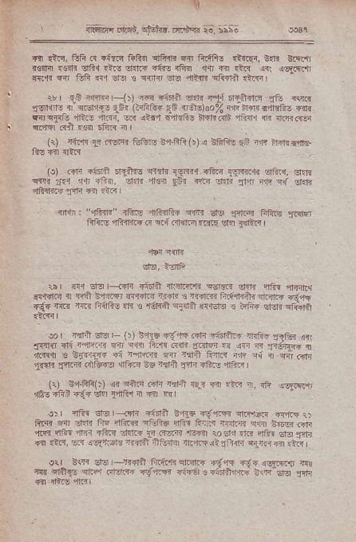
r
rita'a'r i;ltF,'. spj;' ;a,t+ r;, :;Sa
?!ll !trr, 1ifr.r _{Tl?i;r iifin} ^{qFnF.nr} flr{fts .tn€{, o.tn dirdi r$r4 .tlF srF{ *.€ dtL+ €i€ rF{ tlB 1r4.::R {1r {€{.rrn _{slrr} ^{n} _{Yi} ^{F.} ?T' e e1n ^{s-'} _{".lfi} qfr-il',r_d
rr| t {.Jar (./ E .a1r _{Eu rll Fn} ⁻ _{r-.} qqit _{frr{Tr} ^{dr o5 q3} iFr {trh"r ^F _{{-r3)do%} 'r ^{:''d} rftf?' rai Gr ^{r{r',} _{"1t(,} ,-..i, _{?i} ^{.16"} _{ia?h,6rFar} ^{--'} - rrfli(r R"r{r dl) *{ 61i3 ir I
^{(1) aidl} _{Il ffrFi Gitas ea-ffR(t} (
_{iio {d {rt.{}^{nf.A5} _{EB} r,n tir1r fn€- ^{(r) lrF} _{"r: Far5} ^{n'r} _{1:6i.1} r'in ^{'.9@{i} cf{2. ^{!-"re} _{rii} et ^{iF} _{F5} tsqq
^{inrl} "1Rdr" _{lFrc} ^{.ifi_{rf{r} {rfr ^{si'} _{ffie} ^{fif,c€} ailifl _{fti{E} ^{,iliifii-?} _{n} ^{q.{} _{.rh[.rtr ..llp} ^{]ia} _{1inti"} I
Eir, iErlii
tbr ^{Fi El-ir<dFr} _{"full ?r ii'k} ^{q63R} O?]i t]ffi ^{'n4.n} {
_{si(t{r@ ll rri't n"i.m} ^{qfir.4} rgdr s trrlm fiifl]rafj fi:dr. €'9{ _{"€-,tt} ^{q{'i} rc.j _{ftifie 5i s $AFil} ^{q$ft} s.{.rGro e ffiri _{e&}r} qifu1
ro r riliT Els | (tr) ^{3t5} _{<"F} Grr rinnr" ^{lrnFi.} :'1tu !{ ^{-fdf} _{fj,"1.} ^{ri} _{r} ^{e} _{{ Fca 6{F} ^{ll.l@} n ₁₄ ^{-.rijr1*} I 4r4{ € 9i.rtF d ra1.r ₆ ^{'r1} _{ts-?{} ^{-r rq <r} _{"-} G1t 1<ni _{?d.,ri ci&r€ r'fi.E bo} ^{illr,i} _{rl1r} ?6.e ?rfid
{\, 9'filir:) ,r narr cd rca ^{.0.{} fl ^{.E n} _{d? .rt} q.l ffi- ^{fli} <. ^{Ei"r t"ifi1r} _{"-i} .q
_{1),} ^{E+r} €t, r<fr ^{{r5e ,i-4,\.4 d('.r}..} ffi!r _{ft,4} ^{at} t- _{4t} c+t? v-:re dn ^{+..e rffi} s { ebqGf' ^{'r!! !1fts drr} _{"i?i?r etd.r,T1a@n} ^{'6{{)} 10dr ?rii rtll. ^{Eitr} !.fr
{i _{:h,} ^{qr} !6f{iorn ?.i?_i +ii{r ft,rcll _{1'Rfi} ^{q-'i.J?i} !i3l o{l }ctr €r: | ^{-rtdA} -4'rrr cf,.I." rg4 .\6 ^{js:t4v} e _{tir} ^{q{t} _{E} ^{qte} ffiF _{d} ^{jffi} Fa€ 3 a+ ra :. R _{Eri} 'pi
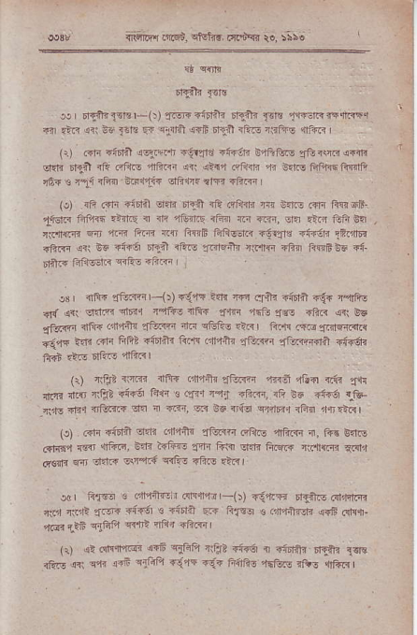
^{J.r rr-{nr} _{Fr.} '-(:) :r-* ^{iid?_li rJ{ilr} _{Flt} -.rr€ncnqrn. 41| .in ^{a?i E!} ]€lt 5r <;rlriil{16 r]Ij't rpE ^{nilis} "if{r ( 1) iirr +idrl r-1rr".[ ?i1{3 ?{r'!]i ^{!'?i,f,4} _{Tii} NF aiii dnc d1r-l _{?ie rii,rG dfitr{} ^{qri qis?} rrliriB ?1 E rFe fqfr<. fiflft rt? . rai 1F_i EF11ii !]FltF il-n diR i
_{{J) iis} ("lr _{itrril} ^{qnr} rEi} ?F.ri:l{r4 r{ -.F r"tr lin rif. _{1.rclR} fr'f,rin ^{.>tq} " ?ri ?E _{tt niT n} ^{lm,} o15 rirr iiiir s. _{rr[fi1 d-4} ^{.fi:T} ft@ ro ^{Fq6 in8na.i} _{"i?ir} ^{rtrF} !?riF
-iiF <ir ne riin t1i riE _{:rFr6ih} ^{,riia]fl} iFl irqfie ri diiF _{EfltJF} ^{q.E!} ?i.F
!s iri$ _{.f?ifl} r-(r) rq-fi i.r.l ffi .JEri iiorfl r=e? i"cJfto d{ _{asi} ,:r.tn ^{elr?4 r4ftu ilFr} *r"r ?51- ?I.. iff< 41 e6 _{flrfl} iin".:fi4ft{ _{lfiiFr} itr eEli-.irlr ri.n .m1rirT.".s _{<,r?} ifi .in fifti .luih lir.F _{.'I4ilr} ^{,Jlii?mr} {i?i.4irn ifriF
(1) lrtt _{<rR} qrfri ^{(in'4,i14} _{Etuiii} ^{'1ii:;1} _{rG+r ifa} .J,ir 'lre d.s _{rtiie iirA} ^{j} r 3 qi.r i",1at r.i?m, {ii ne itur {"ta Ii,|E rnr rl34.r _{.r.r i i-ir, w a6 ?rfii} ^{qfrril} iFii 'rn.i6r
(c) .ifi i:irii1 ^{€r'zri r,Itin} _{"f*n} 61ir- _{ffi.n} ^{q,} fft E tF iit{sn _{rlit} ,rift.n, _{nfi t{Fft} ^{-!irr} tri{ Elnr fiffi rifrm qarx dqri fi dini s\rrq.n ^{wli-} _{"liG} .i.il
.dr fi'r-rr 3 .d?ntEir drfltr-(t f1LF dTft.- ni.r m _{{ia wr! {in4} -idi _{s} qisJii ^{qF} lifro _{a} (,ll,ri}En qi6.dq.rL fin ?.t6 _{3laft} ^{q{'it} ?rtli iftrq I
(1) r? Fnfi@ _{arF} ^{qiiia nlit} _{"i{6r} n r:ifiitr ^{EEir} 1a. _{r&!} qit ^{qlr} arF a'tiiln ?i,ir .ii? 1iifio ffin rfr. {llR3 !
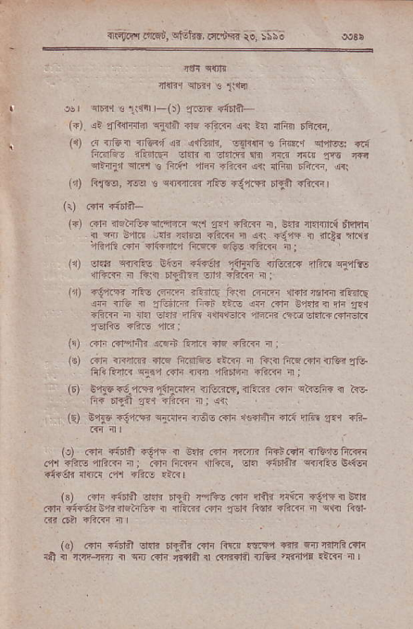
ili-f,i{i!.,r'Fd, cts'trd. nr'* io, bSSo
:' r€r cfir
ifiq ^{9Er.T €} 1\1{
| @ | al'il ! _{1i{!r} r-()) ?r{w {.fia-
(") it _{3fffinEr} ^{q,Frfi as} _{"Fi?r} ,4{i tn llFm 6ai<r,
_{I +a} {ft-.f $ . r7R c.r?!F € ^{4qi} o14-3': {i, FFrq -rt5? _{dfr T} ^{qttr} n _{w} ^{n4} _{f4} @
enirEl fta! ts nr.i'r d4i ?Rm lri fd EGirr, {1
^{(t)} tuqu, _{Trq B} q{]1tr{ ^{qRE} rirr,{i rqn rF-i<r
(r) (ifi q{da-
(+) _{R1r nrEtrEF?ft.ino} ^{qii} "!".r +FL{4 {, 6?rn 1{rlr{ dlirlJr a w n{d ird? _{{:ltro -ftF {} ^{qrt} _{<4{} i sliir rroii
_{4fu"rft.di di-ftn fir@} ^{q&} _{+ft1fi} q;
' ,B' * _{tr} i. ,' _{€€r} ^{..-i!'a flc?l!} "e.? Trftu ffi T R{ rlmi rr ffin i:
_{Fr)} +!*n" ft€ ffnr _{?FatE} ^{j?i{} _{ffi} ^{.{a?*rnr} rftnlir !{ i,e i 3.&dinr ffi .i3 ar .cl" e,t?]? rtFr iE,l -l?.ri i _{{n stm iliii r{r!!t@} ^{q|qm} l:@El"rRRfisJR _{39F!} {Fre 1rF:
_{{!)} drir .sf4r} or6.n tu r rlq ?ft{ a ;
(E) @ri GI'm {fte ftoiaE.rq i ii.i ^{fi.q.dqirFr} Tte _{FdituR} ^{q{il} ."ri _{im} ^{qfnd?.n ?fir? i} i
(E) ^{BtF.:!.'r.ae} _{ai@r} diriq, _{iaR .d{} ^{qt} €ft{ n hE _{f. Er,Fl} ^{p.} {q@ { . a: (E) _{B,rF Titfr c..F.,rr.l i,€s} ({m ra?flii ?r! {fi" q.{ {ft:
(o) ^{.dr} _{"iriil "€"l-[} i Edr dir rqcrn fi+bi"n $&1Efi.rrr _{.'ll} qhi€ ,nfi.rri q: .{1i ft.rr rtur, dn _{"{6lrlr} ^{q{} fis B<!! +i€63 n{B .+r s6@ €lc I
(s) _{l?lr +inr] er.h .rr.il} ^{,l.rR.} .rtt flr]i {ritr i{,r'rq E?lr Rr{ rtuhB,fifisnrtu{ { {arn.{r1l-ri fior. _{+ftq x} ^{qi_{ &.i} i?n 6?r _{+ii.rr} q
_{loJ @n @? t'F Fnr} ^{(.F} _{f@} ,E!d _{aE} ET'rfi@rr _{4t} ^{q} ,:E"Lq { rr .cr" ,r.nt { .qT.4r$ _{{Fl} ,fr.F! 'r@ { |
^{i}I_{I}
{o) .Tri <i6rn ?{4m _{ffii lnl'} ^{,liin'l3} _{{ ri"n+{rrn-r} ,iF€ ^{,ftriii} .em d,ntrJ4,?Pn dirTi n : ^{qlin dnf.r]itr} _{ai1rtr ?n?} g,q6 _{4'n1l?} ^{q1ift} E?! ?iiq l
^{(t} _{1rc {inrl T6ipr5Elxl} ^{'4.r.q6} rfi.r? ?iiF l
f r rc Gft r-Fitni i.! rE Ft {irri'F
_{{4} gI.1* ^{'frc} _{4".r} ^{qi?rnR} fld.nilF. c'ft
(1) e:rdfii1i fim !n:n _{a,} qf{
_{(t)} ^{,rirrfin} nz?.fifi 5; c\r{
_{(!)} ^{q'il'} _{- eq?r} ^{qao} _{.liaT} (]@, qt{
^{(€)} _{ir..Ftirc} ^{qr.1} _{riil?4fiir_{ .r} ^{q} _{tFsq€iR} ^{qjnEnnq} <Fn fi.rji:€ i, {t:--
{q) ffi ir sr'i{ rFr.+t ri!ftli n{,i:r a ELi,rrr !.ir.{.n
^{if@ d.rn} _{T{r.rt} ^{.nF} _{ier rn- niri,1.i .!:i?} q{
nqFq pli ^{'tFrr.tr} _{eir !'?'} ^{q6m} .if@ 6+4.-0
_{asnr i s,} q{d
(q) ^{?.1_r} _{1?rr dFriFr{,]fe m l ilnr} ^{:_}n} _{{.ri} l@,
^{(r)} _{Efi.} ^{qEnr.,} FrG ffi'1 i :tsli,i? rni r1{l -; e{i
^{(q)} _{<-4.8 i i'Fi} ^{jim 'r4idr-@} i -1-€ {r.l Gia.i, a ^{q.ji?} ?rl li3 ^{riirre".ifl n. i1?} lqrrrc*+811r!{,
e{i <i'?q nm ctr6 iFs {gZ .EfiEr rA4 n. rim
_{li@r,r.} ^{?J?.l} _{"rlr{} 4, iF Ftr ift .Fi r i{nm ft{s
^{rrl"r€4e{ din} _{"rd} li? rlir'.!r lii n.F.q Er.L.5r4j
ftq ^{?H} _{<'1?} 6E +ldrlr9,i?<?i {?1k wlRia?ft-'r11-i r
r! _{rcI;IiF(:)} ^{qn} _{diff{al3} ^{qrA!} ffcf6 rqT 4i?ftdtl (") turc.:re:
(q) _{nf..t iflnrr} ^{qd ,E-41tr} a r@ rir- f,l- ?r j
(i) 1 ('rl-) ^{ftR} _{1r} 6sfi fl,lBdr fia FEr l
^{(c)} _{tu[6} sa'i! :-
₍₉ ^{qftr.} ftfq @r@ i .rsr6.{r _{aij@} ^{!r{r!-nl} i
_{{q)} rfdi'} ^{r_6{ ,$ns} _{J${afii,} ^{q'kr{i} ?r."i _{riilDAs} qtt" atu ^{q,tli.,l!} _{n} ^{Jl?lrj} ltrr1q .@ ? w .fir {.6 r€nj . { sLB _{r4€'.i6} ^{qliimt} i
(:l _{{fsEft} ^{q{llr} $m;
(qJ _{rJtil ?i?c} ^{q4rhr} i
{E) o-li| tt- €{rd
lr) DT-e- ^{c--<i.,+F} @ w o-$1,n)-]@ m a +fdr :.Ki! d?,ir r ^{="} _{T!} ^{,fl !E'rr} ) t.t ,r?i I
_{-ri Iqr-} ^{tarq 6+--:-} .:3?ry4fi. (t /{ rtJ r _{irstni} ^{dt} 4{-
({) ,,1it +idftr ri'i€ eni! nnr E6 ci.r'4 6.if{-€ sltu EnE . _{1&G} {irrh r 1i.i'r fir. dAFj
⁽¹⁾ i6 .{dt}i ^{li€b rq @"} :rltfi uElr _{rAR. .E im} qriarl ^{im} !rT!".fr _{Gl@F} ^{rri<} _{sr5rr{ idfto} ^{qRr i|?j R'iE ?6G} I
_{{.1} l,tr{ ⁽ _{) r {i'F} ^{q-:nlr!ffi} fl."- e mtr..Fr _{"rn+r" n:F} ^{/r,tF} nr dF3 ^{- fr} _{13l-} ^{r lqr} TF _{€R 1!} ^{qt_i at, a fti?} _{"ftr} ^{(t} _{lii} ^{,'d} ! .{ ir, 1lfl.@fi
liqlf€r ^{ft{qnr} l.dt _{ffli} ^{'r.$dl-r} n?, _{arrrd !i{nr} q1{a Yrdr _{l?n} ^{nr !tu} 4l
()r 4.? ^{o, 1{} _{It f)} ^{-"m} _{ft} ^{qr€ ffi} _{IllF} m, ^{cllT.j} _{<1'} b_trq ^{';nfl} _{rdfl,r} ^{.rT.@aq} r.F @il-rrre
^{(q €.r Fls} _{r') n} q;h ^{^1,} _{ra.t.r$} ^{qrar-m} d.3 a{l r{q,q} ^{d i"iF} _{"66 e,(F} .-. ^{r} _{"f-6} ^{c'@} . ." _{tr?^} d. E1,r4 ^{Ed} _{Af5?rq} ,{ 39 @Fr _{ct c} ^{arT{} _{1r} q4,l
30 ' _{ir-'c!r .m} gftr,rJr ^{_(:,} _{D 3t"?rr} ^{qft? d} ?$Flr ^{F@ +rtsil} _{Ir} {n. .Er ^{rr- {' El e\c,? 1 :it* @ qtu4'} _{Fris} ^{,>G iSqF} _{?d-} ^{rrr ,} _{r .qF} '- ^{,l'1, €} flr.s Lr, s|. ?iF ?;lr
_{o} ^{qelB} ?rc. €€5 _{srflE} ^{qF.dirIt} _{sJ:ti? ffGer.{} qrrltrr 4!: 4a{ | cvd-F _{:t'1.} ^{'r!} 4if--. 4f _{ffi} ^{qFl} F iqfuE ft4? 4 s. tn ^{r,ft"I-.} _{13 rrr-} b5ll 4'€q ?r-4 & nl _{El{l} ^{qrall{E} {d ^{tul} lsln Fft!: a{\
<'iq ift.68, ^{Gffiir,} ffit E6,
,{ 6(!fd rnr{ _{L!a} qGlF n<€. !-a{ ..i'ft r{s:.s, r _{ii!} ^{q(a,} ' ' it6r ':n? _{rr} et? -E ^{qF} itu-€lrF _{r.-n} >r'(lhl +Fm _{fi{r,} ^{q{} sl.i + ?r&d!ELc sn1fri t!1t _{@in} 'ln, cr{r Fiafis _{rllc} ^{qii} &6 h&:E _{t+l} ^{,n} _{"Fn} lli:€ d.]t?
i9\ cif4 {+c 1Fr?:
qi ^{'E {ti" F,} €4T _{5Frlfl} r.n +F.a, si"s nk{ _{r,ftdE Erni.rsa'R} ^{'rs} slFrr 4nirrd _{ft5} ^{-@} _{4'r} qrEn wg -i"6 ft{t {i'ri xflrrrit flRq ?itn ^{qt} EF ?ir€rt{ tui'l 1t€ dF.l <<i as$qFn a+fi l4Prhra fiAir rfr{r ftrI
t{ _{sr{ril?i"€ri} ^{'r&rnn 4ni4 ?3,} _{"=eir} Bi.l.i fiqtu:F.l
ffin'q"ri, _{Tcllvl njr ?Frc,} qG?6 g?@ q''B ^{qlrrl} _{FF} ^{'r[t} I _{ilr} ^{qe€i} _{@rr?} ^{ef.Fr} ftq ',rn _{Hd} ^{*vm -r.sa} "fl rq,q4 _{rgrs OFiB} ^{'F{} {ft.?l
rs) @E& trsol<? rc ({) a (r) K' ErFab +Ji{dL1"r' cri rrr+ r<ar, _{cr} ^{qoa'} "-F| o<.. ,a ? dr _{lq} ^{ql"} ! ^{efu-} eftq _{".i @} ^{o:jrrl-} _{T:n.r:} .+n .-_tB ? Fant ro Fi c{ 4l>.s .Itr..
(q) _{{:!,rs} qlit'6.,tua {,ft'€ lr1fi _{a@14} 4li €re: _{iE rc} qri4 _{"t(6 4rrj} q'tq
_{/1)} qtuS irl6 ilb,rE€lr{ n.?eE cr .rG i i?EE .lrc €1?l?
(q) lrfi'l3rE _{r?t} qqB rib? e,E ?slFr? rfrE 4li4 c{i lqr 6+'r"! (t,Ll) ri (t . _{f'.1Etu} '1"i{ 'Ta 5 -fu!
_{.a'} .Ji.rb +F ^{q:46} rtu" if{ ob (r) i6)tu {,{E a ^{..1r} _{1re} ^{qtF"t} _{ffi} j
Hr _{ficlB13} ^{q'r1'} _{ci_riq<} ^{q.niEF} _{c ail} ^{5i-} f"'rq !"-m{ _{r:r} .1tu (c) r.F: _{r\'b} ^{e.rir} {i,!.
_{d: qfq{.i} -.f-i ^{-n-} fn3 !! ^{r.r} _{t4..,} ^{dr.&} @ @ % ^{xint} _{"1na{} I
^{s)} _{t@ft. (ri:"-i} ^{'54} _{| l')} a ^{lE-} _{-?*b->} ftc .t _{Fn4rFn} e,rh _{(n d{-r} '-Fi i.T _{, 4 ?14} ^{q71} .4't @ @ qGidjr'.qni€ ^{It.q."li} _{"l{i!} ^{qRM €r} _{14r|n *x!} ,nr,o.arG
_{1{)} ^{qGi4rJrh} _{fl.E} Tft!,4ri _{fcrFs} mt Fq B.ns EGi ^{?ftR} ' ' q( (! _{ff4} ^{qfu,h} _{Gtu-e} ^{qERrfihl8} :l.fls .i{l.q B{r &€.r ^{a1} _{"!'ri} etq'r _{artfi} rfid ^{qo} .q rr€ et{ ft.rilr ?.in aal c,fl!.j <.i sr.J€ rt61f,li{ e-rFs d?ir I
_{r.)} ^{4!5irl?ll} _{rJa 4Eiolt.f6 !(z)E r+<{l {a} qFqq _{r{{r {ftj irr+, ff\.-} !"@ 4r'f€rln54.€ s'3 3er
^{qnir"r} _{{'l ?irr fl} ^{_e\flr{} 6d i{Jtsc +n{ ?ilifl ari trF ?ri6.r5t.r Bfiii 16!r dr{.t _{4F i? n} ^{glrle} Ec'l +8.{.l ; ,r. {r {E _{., fi{'i€} ^{(rp.ri} _{".r"} 1rd,"?E"3f
_{"f, 4%} ^{q rJr4q} f.f _{sE} 'nd ?qli et@ ,bF larrc _{futu_d"r} ?ir s rrjtr Frt ?{s ri? iiN frFR|
_{ril F.l!-} ofrr? ^{i;f6} _{F} ?r. _{41.} ^{r:@} _{4d} qnrsntr?h14 ^{tu6} _{"i' {E1n adn f-,F} ^{afiat} _{ln15} ^{m} _{Fff4} ^{€T} f'{4 E;fi ^{iJ} s f|i"F { _{,F J eE} ' _{f{.rDnh} ^{'n} _{" ittr !€} ^{qrtre} r{!{
_{l"r r.{d} .trdc ^{F4} _{TF} flia7tfi e'Pn dq _{4la} .\? ^{:tt} dt lid _{6r} ^{s} _{?:ol1} ^{4t;n-d} 4h.4 4. r.Tr"i _{n4} ^{d5fi} fi-a alRi
, ,' ^{?rlFc} _{irk F@} ^{'$E} _{afqi} e'15 _{iq} ^{'i|1} _{{tr} €nrt ^{H.'4r|} _{T!:1r-.c} ^{4Y} _{lT} ^{',rq} etF t'.iG _{t-tn aI@} ^{.ry'FR} . ^{r;rt} _{rrt} ^{r'} -rt 4 ?r 4di rri :-r, ^{n,} _{"rB.} edr +-t @"4 _{En.1 r. { 30} j{ _{d} . _{.nsB"-,} +T rr sE _{E{lr 4 rf} . _{"ri} r+n ^{q{rr{} _{aBN} ,f6nj qri ^{qqt|4} ii6ie iiFl fFF;
r1t !6
v" .,c ,mi !.s n vr\1 ^{w} _{d @} -ia .'"J.'o4 t- !^ ^{.iq} _{nl;'} r:e ?ii-r rri6 <?F w rfi"6 ttr {F.1 |
_{r .1nre} qR -€ -{'.i i d' , rd _{e r!'?a} r6?t?r m RRr r.!r, ^{."r-.n} _{"r-} -n.1e rqt drtq +req.lFl aai ro *n ,": a d, {@t ct r { .E 6Fn E o ^{.iJB} _{"t'} sfrF I
lsl w"ri ?.fti I .a? R. in _{{hF ersiq.tr} qldrElB:i.li! Ffi |krRni ra$ si:s. ?ri ^{e+} _{"Fnr} lri tiR sr a ?FrE t51n
_{6rc €re rrt m} ^{'FR} : ^{'Fv} {,!! r ,t _{"d@} '58<ad d?D _{€lq} iti Fr{ri- iw Rm r ^{\FnF.!1} "Frn _{ro, !@H +{rrn} ^{a?n} f:nnbJt@ rRr _{4i:} ^{aF} c :: :.1
^{4&l.ftr.n} _{"';-1r€ ft61efi} ^{qffiiR} I
_{5l} 'r-r: _{4'} ^{jdird} (0, _{trr:B+} ^{'16q. sri-it?r'} _{fth 1!} '6 t _{rn.l} ^{.16l!! a} _{"f :8."b, lroei} :'nt- ^{e} _{"ri} 4 s'-{r*
^{rlEE} _{"rcfr{ri} {4 -t-11_rhq iiF:{a trrn' frr I
rn4di,r _{snqd,} ^{qi€ldd,} .6.d-{r re, \55.
(1) ^{i;i.Gir} _{ts)} ^{q{h} _{ilir rl,rr{ .tF nc ?h.i} ^{qrl} d.LtF ,Llzli iiFiF rj-ti !3 nii-nih _{iJ? 65i'r li6rl} ^{g.'r} diF 4i! ^{qf€F} sf6r _{lti} ^{.i-F.} ifi-.?
^{(L-t} ct i.:Iirqlr eil. rft _{fi{Fh} ^{'liPr} aiii _{:tlri} ftFnE _{rl"Fl} r c-/ i r'
_{lil} ^{jr4} r fi :P Tridr fi ir- ran
_{"{r} qr1.Ir
at ^{'/tt} .+z "ri411i1-()) ^{.iiii;} "t\
(r) ffii _{?isjr ail} ^{,trritr4.} _{e4.} -
_{(i)} qr-19 .:,!i
_{.f ri4} ^{qfrt!} etiTh -.nr- Fl !r1 sG41,l _{llri} ^{'1[l} ! F _{r- -r .:F r:{} ^{q':.!t} t?fft _{.. 1i} ra h+ r r :--rr. ^{ral :} t1-l.l - ,rr rr i r:-::?
({l ^{qli,? i,E} _{{i.'n"i} ^{rF:ir.i.} _{G-a} ^{-=r1} EF. iEltslF ^{,r;r} _{J1r} ^{ziF} _{fi'} ^{_ir- -,r:} _{rfi-f^J} ^{.?,i .'ib.i} .rF ^{jidtr} _{nrr...,} :rll eJ:r.,:ril .r,r,
lr) sEri.ir. ni. rFr _{t4n1r.rrti.it ei31F.dF iir} qFrr ' ^{'?rn,r.rii.ef} _{-F} ^{qkijrii} .i;ili ^{{'r)} ' ql-iErtrG-JninFFilir'tolnt _{efl? .Ei.} ^{?nGF:r,} F t @ _{nFB n'rih} ^{q1,r} ftri :r.,.il 4?ft- .r!n .ia 1l
_{"'t rip} ª @e" .
4rr :rr {r- ^{r} _{l:} | -r_ir: f:Frr iii.! narq l
rsl .rFFJ _{r,ir:ri llin} ^{qG:iEli} n:iriiiFfr ndd''ifli ^{-m} <f{ a dni { ." rrrfirr rlft rrftFl
_{lrr} ^{:,:dl} _{-..} ^{ila {1} t= t,,r.t _{d4"r- i} ^{'4} _{.-= .bt'd'.:.r'i1} i:1c-3{ ?_:{?+r _{h;-} '" '"''" ^{=t} _{1.".:''|.} ^{'|j.,/i:a} ih **.re=-
_{1{.} ^{,r-} _{Rmr} F _{T} ^{a a;: !@.-} " ,' : ^{r} {t3i lt lttu:
_{r{6fi{ nrcd,} ^{qtohr,} di,iF{ i!, $5.
\". rrenn E+rt ^{n+} it {.i rlr F.. rEs {idr 'ncq 'Fs _{n{E ,?@ti} ^{arut!qfl} _{i} -@@ ^{qrFrt{., e. ft} r'ti
€\r4ft.1'l,r$1i rlirii s {ift13 liftqn
_{"fiRr lrl} ^{jiRf} -.{'r,f.r
^{q!-e.} _{-rliFri} ^{q.e"} ri,lq ^{i"r16 frr@} _{"fr.Efili} ed,r) GrdR 9ji16
^{ntu fr*i5} _{1{rda} ^{ri{fi} _{1'i} ^{.lir} _{"rli.r} I
_{f )} ?rnr -i+n _{7rl} ^{-'r,ii} - Fri ^{ntsi} rnF _{1F*!n} cF n 4i1rr _{fiii} ⁽ fi +li..,r I
_{(br 1'rld} ^{.n6} .eri { Dtrr F n F sa{@.e.--i 6itu ^{rfrt} _{{,En,r.} rt rr fti€ ₁₋ ^{'qG:r.} :.. ^{.dE} 4 d F9 ?-
^{ii)} _{"q'?r3r} ^{qsnq} efti !ffielrh r, ir.1|l fiF ifi{€
a{S EE ?ft,F fi.rr1 ?'iF,.i3rJn rirliR ^{GF rl 6ri fti1} ra{'i, s& {fiB:r ft.Ee .!i1 {.clqt rEs st rr Ei3 i
()o) s?Rr{ (i) ! etrfti @ ?ffir.{h t{,lT .".t. i"s:!:Eirrn ^{qd?fnn ?Bfi B?} _{"1"'6r} cF fl{5r { fiff! _{rfiB} ^{'Ji.,f{} riir ifqt{ s\ii4r,i i?Fr 41 o\lr?Fi a?r !ti3 x i
soi fifi{ rn{o r-(r) _{1iR or ar} ^{qfin} _{.c.ilr} ^{qFr{r/.'ti} ?tr Fr{ _{r-l6iflr fir-E} 'l+?€rn3.1rrsr11' ^{qf{ic si} _{Trl{ft{} ? rfiffr lrr {fta, 4q,rF E6 .irli'i." rFrli.irrr fi.l3 sFc 1rii.r:
^{q-r} 16 \'rc c, _{a.:,rF} qftr€i qfinr :Ir aftF, e6 s'$1flR rF6€drr rlrld ?iri dir.5 m. 1r.{ rrir E5 !ne* _{01iF::} qfi,l .trs, ^{Er.R} _{9Fr {l18} ^{rr.?r, 3r.rl{} _{!,"F at{R} ^{qllr} fi.tu _{ft-} ^{,Jrrn} I
(1) ({ r@ Fii rfulft? 5r{"fl e'.:3 _{ii{a <} q?iR..B qEf?s _{!5} (+h ^{qrt€ rt} _{dtarrli?:r li$t3 ii} ^{q,rc} R€ _{lisri€i} .iF _{e|lF {} q{6Tn rFra (rj,i- I _{{G-a{.} lri _{+<1t ee clrfi} ^{,iiF,&} _{ti.rr'l6n} ql _{s!} ' 6FlF . c?r1. ?ri
^{q.d} I r4r .t lrF .) ^{.r.lr'r Fir} : rfi ₁₆ ^{qira} @€ n <irr, _{n.r..r} ^{gF} _{+irrs?r.r 1} q41ll.r ^{rj-iinE} _{1:]} ^{qlit.rr} efil.lfi G6 +irriJ rlnfir€t? n{! rftr tn _{,is} ^{qri} _{tr@r a} q€rl ris ffi ltu_r _{<.de} ^{qrfiGr} I
_{{e)} i<]r d5ln _{rl||d€El. <{€} ^{,{Fr{l?} I&a ron +i*ilzr< mrt ?|{1ls1 ffi ! s]frl s{dft _{cll?Fif llo} ^{'41aF} L
G)4q r Flqfln _{cziri€ trn cri|'nj} (fl,f (iFrd.i cndei{ ^{qritsr_si} iFlR! _{r1i. ritunr€} ^{qdEF} rl fir !irq) dnil.{ q{or.i?
fl r{ r@u', ?i.l€ rri.d<r r;, >;:o
^{qRi} _{!t s} 'l|{li-{slr_r c?{d rlitr 5Ht ?Air .?.. _{lri d.ti ft€6} (?Rli_ _{crqh} ^{qftr} _{ii. rri4?r} ^{q1iflrg} _{4 .€.} ^{-4f.} _{lci-' {llali} ^{(rriql} sre ?ll_f{r i ss ! _{6lFf4} ^{-(t} !fr 1ili $r(;) 4f?ffi fil;r-srr r3rs 11 ({G _{Rlnn} ^{jh-: i",E} _{"ri} / ₁₊₃ ^{_{o} d{,'
_{fr} ^{.fla.} F rflr d ¹ _{1d} 4' :iF ' Fr o ,'n t' Tr? ,F _{Flen .r=} .. ? ^{+tl R !} ^ffi Im ^{ffi} _{ti nar i;iF. i!!fl 1i4} ^{'i'F} rrr .in i
a.r _{rd/i ()J} ,, _{frr ::-} ^{'r.rrFr'4r?r€} T,itra.5s _{rffi'l f{rr_.{} ^{.-:r.,r ,..r.} _{r-_} tr (!"$EG" sd\i.c Rurct 4i il,trn _{rg|F} all15s ii4j!€ .?'ri I
_{/t} -ir.t]n ari"i.t i]1.r_6 irPi} nrt. I riiri, {'ir :-
lrl!?- fi+14? i _{llir!} '4-nE ^{,nq.} anr Flrlrq ia r. ^{nr !-l} ' ' riirn _{.rlH 4rr+r} rirr ifi.r nar !i'4r1q i" rl (.\) filnln'ail ..1 4R i..t2.tu 6 ,ilr',rljr€ ft r:
(iD cirrr'r! _{'! ihfeq?;} ^{,iiil-c} _{a} ^{q?{i?} in r
(J) lr,rlr iqq,r Fi? i,rF rtfli ^{GF6a} "ri.r
_{Frsi,} ^{qf6j?r} iai.tRr
^{3r} _{tiil.4r} ^{(Revrw)F(:)Rri} ?trril rq4iTr odnrti ar ^{!rq4q} 1]1.. Rri sier _{1hl} ^{'rIq} (4sdev.d) ?i.i ^{ffr t clr{4} 1t ^{firli} _{{Rdip)} 6i _{iir.qr r-Rb} ^{qErri} {rie dli.r'r I
_{(r)} ^{qL4} _{afi c} ^{qr-r} rF' itlF ri?.qi .rt €rrfl EJd(" cifie +hiri di1? .ft tu inTj ^{:]t{i} _{1.} r}ftqr ^{qtir.} _{rar} r t ifni6 erj !t 1
_{3.r} ^{'fii} $* @, crr€n{i.| rii-r _{rrri€l} ^{q|FF} .'?t ?iir€ { dt?'1r 5l!5 {i!i? _{it} ^{.t} _{Q?} ^{;ri} _{"i1r} i ra.n .!ts !Ri1s mfti .ial i _{?*'r} ^{t6i} nr.ii ^{iri} _{"d."ra tlilrf'} el.rq, :]El +jir6 nlfr.r I
_{ir, 1,?.1-nr.} otl.i ^{'l1n.} 4- {€*4 <qd .i46 RFL,|vli!. _{ni-n eRrr} ^{'-qrn} _{"lire} ^{'fifiri} I
_{3rr} ^{qFE.e} iihlitr ati{ir r- (!) cn rnrd}i,4mdi ?Ftftr5 ^{qr?} Gwi i..ii Gir 611r1;t _{fii n} ^{qftfi} _{"iiilll FEriHlr} qi-.", sLi< ^{lhs FErftr} _{"lird{} n|'rr 3 irnri elr rl{l diiF 1, frq aft ^{l!{?{} _{frcrh} ^{qi{r{itl} EF if,rriii t4r lrri re1.n4 ^{irh fi6iR} fi.r ?ri, sr{ .aGl n6 rt4 _{rr} ^{qF,ds} {lidri liq& ri r-4T i rerr d{t
(i) _{Rti ?{fi'_l} publcsrBib (Dinisldr ou ddidiotr) ordi.ua, 1935 (v or 1935) ! rrFi Fr4 _{e'riJ{ irtn} ^{qi..?rr} eaa.s nir _{.+|1 crch€ !!:a} ^{(i]Il} firs ts l14 ?lE€ {iE, 4ti.t I|sj]! +iEril+ {n fr ^{i:F]nri cft.{,[rB} !.n, rir rl.r ft i iqfi sEi &i ?iidr i
^{(!)} rq,la _{ir,Fft1t} qr ^{qftr} EFE-{ ^{{re} $ir.R ^{infi!} ?r{ 4fitn nffi-fe€ @4 l;46 fcr firii! 3 {d,r+ ^{(rti? re} $l1 _{?fire} ^{,it6 qri liil tu} 1{riir ^{err .?t--} _{"t{nri'} 1bi ?iJr f.rlqr
_{G) <'nr r4fif{(o)} qi ^{qftr} !6 rdrfir ir3 .rtr reFF rl rrr. liJdl!..rs,l RF.n ^{fta6 51rr. D,irj'te} _{ti.rr} ri rrE iFn _{liEr!} ,laE * n.lm ^{r{rq. e$frr 1!{} _{"fniE} ??ri l
ffirr #, ^{qr6hr,} i:iidQi$, flbE
--
^{q'l} s{lq
?4fefir'ft{
ahr cFn lsFa F(r) {94q B!1r -i!il't{i sl ^{qrF} sERc .f,n {fi.{, ^{ne} _{r(w ?i6k'l} ^{q(} -i'nr ml? rs._{ 1.{ r{ fi4rfiE _{:ne} nn ?Fr,r rft! <ir _{iF @hsii4rs ihii ii{.l} ^{'r{irn} _{"-e?} 1+€ Conkihulory ^{Povidcdl Frad Rul.!,1979} _{fl]lffusGnfEF,F 1qllE} ?aR I
(i) 0a-F1i (:) ^{q?} frdr rtr€, ^{.li} _{4ft4Tnnh T{an} q{..rQ-q ^{,!.i} _{RBirr} ^{q$} _{lqiF} Efts cfiq 4t dtu _{{i} ^{qilr} tffE .i:.rir dio dqr dirr eri Bv ^{aj?.n BFd?} _{1ie.Tr 4:i} iln fr{ _{! 9. -i.-} qftf{ _{fi@} 'F- {sA' +lf'Ei a? _{ftl?rlii} q?rr ^{jja-} _{rtuE iFn} '.r{t
doi nigJfi_r _{F(r)} ^{j{fl6} _{s Rtr +i5ln} ^{q1.sflir} {lr_{r, rlr F _{rb,} ^{6+ d} ; trd _{ffi 6rf-a} ^{qhiqi} 1r ^{.f1..6el} .t: _{:lt} llPr" ^{q4+i} F."t.
(r) i'!{F tu{ rcln 6Eit ?3ir'rn ^{iitj} _{"{"rs} ^{q]qtu <iffi+ '} _{5r1il.l.o 4rsnr l srEil} qld l@ dij (d er _{{sri} ^{,F} _{.sfii} ^{'[i} f{]|i,r atire ^{o Fndih} _{m.} Rr'{ ElqliE : {d :-
_{{ol} ^{-ift} _{d fr} ^{r{e} tF_l?.n D _{ii} .]d _{-@/} ^{qfi} t 1r- _{tta {tr} ^{'rl_} _{'-11} .i.r d f :irnqi
_{(q)} ^{qiLl} _{1 qiF|$} ^{qlr{ii} ?hre _{.4fiqr- .line-l;} eti _{ln) rEilE} ^{qriffiq nrii} _{r9r€r} .F.r.E3 L
(1) _{.d{} ^{qtnftT} !r{r _{?F@} .!{ *B a d$i r\Iti! c{4o ,e{r.! ftii.1ffii, r 9-li c{ri ^{r1d d{ni rd} _{rr} ^{ft_a} _{tr} ({ir{r _{{r'r} ^{qtefti} :Frr .i' -irl
(e) ^{rlft'F 'J€re} _{aE} ^{(i6} erT-sfli{ n{dr Gtu :iti I
(s) ftn _{{i6rnr19R dr.r} ^{qr!!in{} 11,n .trc .Er. {6t+s rrF i {,&'lj {r!r.-s Bn _{4ldr} ^{qitdA} .r, ^{@'n} _{fii'{} ri61fr {-! 4. ?g-? _{ffi1FE r.rti} ^{q{} { ,4{lk{ rkF {nm rir {Frtr r
nv'nr,c _{ftei,} ^{qr'fir,} Fd'rr is. siso
(a) ^{.ai} _{"tnfi} Er-fiIi(a) _{*6a} ^{qrfft} TFr< <-rrtr+a in f<a _{-ri1c {.nm} ^{'ra} w|6 ^{r} {@ _{1r} ^{q:i"r Bdl} _{"F7F} @ cq.dFRr
^{'rlt} nh E.n- w-p& r iii ffi i?-d te-r _{@ 4} ^{q} G lrfir 4ftfir ninrfl! Trft,l1ir rrtftlF -1r nfir @s4 .iF i
_{r.} (q) ^{.dr} " i o .+m llx" aFt r.nf!'{ ni, nF n nd
{tus <ftE 4infl i( {tft,r ii- rji?.q, &Fi Ea . r.inrr lE fin(3) ! (a) !r rifi qfF ^{!+6} _{1!-i drnffi} ^{.-fa} f, r.qn
r") Fi riri :-r;- - _{- E} '^. _{j-} ^{.,'=} - --3, d \ _{En-ifr} rrr. - r-i _{r cr} ^{'t+.} _{n .} +. ^{c} _{t/,} -1
_{dbr} ^{q{R} _{sro !} qirroFE
^{(t} _{"{ft} F ^{rnr} d
eldlr{drc l6Fl! elrr it{ i{]rq GFlt @na, ^{rm} 6Er € q{r5Bl
"Gdii
^{{FilE} _{"rri{;,r} El1Tft.E,ii?.r sri {ln'14i_4?4 liors di€ir i@ ^{n"1i .irrai..B l@} _{sff*J} if{rrnr ! &fli -q{ cpri rn rr. ^{dnF crn! i 1di} 4?rq_i? r,?-{qrr. {in4 ri.r I
(r) 01-F1i(>) a _{Ejitr€} ^{'Ji.'r.} dE n dr ?..rr +tufi -e-4r F-.?'?q!TF fiaf.(,lft:r. {n _{E_6} ^{,fii-,,tn} er'€llfF .!3rn {i €ii llq aflr _{+fie Efft ag-'l'ri-r} ^{q{8.} .ftF I
_{(1 se 4ftfl+} ^{'r€.Ift'} _{"ta} ^{q 1{i{} _{r:,} id eA. d
!.+r-dr? FF nni t6 | ^{>fl} :led ^{m c} "lr4 rd :-fr3 r|? !"rrFff.ffi.h ".tl"rr-
(q) ^{66 E{Fc.,ftlr} _{"rq€ !} ^{grl{ q&-} F ftr..r sFlr c?F.dt
({) ^{{\i4q r9-.} _{f€} r,iydi !_{W$i} ^{g4i sks} w t'v ?6 ffi lrtir _{aT ?rit4} ^{gs} dn s _{F} ^{q7}r} A61s _{.n€tR} ^{!m} -f{r _{4?{ran} ^{qa} _{.r4r !lr.q} ^{-i'rair} {6.- dFnt
(d) _{r{'i4 frEls ftt'{} ^{inaB,fie.r} 6qlrri ^{lroE} silr € errr4. ^{qf]g} {R{1fi _{lllai} 0F r15 d{.$,rr Dr{tt-dn Fjrq.r r{ij .d .l_6{ i
:fi! q{1l4
or I Eiri ?]?r, lsr'fi fis_a Aor (x]I or l9?4) ^{,13} ldt F"{dilr qis q.q ^{<li s11Ln} _{:lifGr.iF} in.t.i Plblio s*rvd , ^{(RlriFbe} ) a.r, r9t4 (m .r rr74) ,4? ^{fid in} _{lFF} ?i.r
_{a, 81fl} ^{qdn -r:'} r.r4il J,?1' ^{.q- ih'l} _{!q} nq,Ft 4" ^{1rm fdil€} _{a{} .ilB r ^{lqli} _{"Fn} c'trr 16 .iiFdr _{diir6} ^{q?} rt'fr
.rBi fii {G!r Rli fi-drFrr? _{r1{"il- eIil rilk'nfir} qi! q!5n _{D]{{lr} ^{q{iLr?} ?h.{ l*rlrF,i c411 1I}li fq,F{ d.rn 4 |
(i) ^{q!} iif+ll'4r ld_.F,i]l{ ftg? _{{r{" 4} ^{('r?,} a{,f{ Rlr thl s"ir ittuii"t Gi nr'3 cLlE .it$i iill c{ir ^{ssrfii.g ft4tti} _{ac} i€iar _{r{ntu{} ^{q{ diral{} _{"Fn} .c @ri {{slih _{btEi}} ^{qr'l4} _{rffi.€} ^{.rF.r} i
dsr i@hlr lqfinl ()).alr rltl..il .i:dtr.t{iil rqtG f-rt _{sEt} ^{qfir$r} i,.!r1iR _{fs. rffi 1tr]€} ^{.!i} .ilBl _{$ir} ^{q} FA{' Di{i'} ^{sr|1} _{"fiis} ^{q} Eila'l ?!dr _{iii€ 1ltuN} .dfi.rr ^{;lj} <{ 4a? iifi !fti?
fillr i€! ffi' lfild_rlil ?qn-tr _{eEtr 1in ltiti} (-!ir! ,lr41i{r it.1 Fji'F'l iidF :F1i a1i.5 ilts {lfiFn
(1) ({ a{srili G?.\ _{1i{clql-=€} ^{ir@} _{1!1} !* .tuiq fsir r::i}v t€lfr". _{{+.€} .n<1
sir 16 {rq ., _{h.} ,i+lil .8-4r .{r frrq ola alr4 i{rvt ^{ilT4 fi.r5ir} _{"fiF} arirn t6 c.{r ?d6r4lz? lv4ith ,li qfe ins
^{q.'ner} orri, ofclrr aedq 'e :!ho a $,8 f'
^{E ,.1} E Ed E
^{P}E
E€gP
P F _{t'-F} e *
_{EEf.E} g F€fE
^{F}F
E
f .E F€.8
fiF,P E €
5 dF EF;[E F
_{P Bg} ^{,F,€!} ;'-,E
F EE EEfEEFE
_{Ee]',8} ^{E} ;
EFFFBS
E EE F
FI ^{F}F
I
gh
7
;
€
_{rn6rF i'nd,} ^{q'tut{f.} Fr.dc{ ro, >rho ; E" EEF' F
F E .FE: E
E:
EF;EEiF lFF : :Ss: E; ^{rET} ,I u'5rtF rEE EEFIE EEfEg E EE
Eg 6 _{Ei;} e _{:I F} .E
E:gtT _{F+E€l} TFC
_{Fs E,g F} ,FG
E_{F}
5F
,EE xX
$
7
E
⁶E
s
"EPE ^{EFEE} txF,E
t
E
5
;€E
d2FS FFE
E
B
^{F},F ^{F}E
F
^{F}F
^{E}F
E
8
^{F"}E_{E}
E*
42E
.r4.rr rfFu>, etutur 4"tqi te, ibb!
E.d E *
_{E} i E'Z
iF$ E€
^{F}E .E
^{€E}F
E'6 G
; _{t=i:F} $t' FtEq _{'Fb!g}
+:$ ;
_{F,F.E} F6F
iFFE; E.q!F€ ^{F} _{E;:E} 'N!.EE EGd l{ EE: E:
FEF€i F*F EF
_{F} F"
lF_{r"} !E ,FI F.
tr F
F.e ; Ee€
8
F'
^{E}f
_{Fi-E} F
_{E} gF
,BEE
^{I}+
EF
^{E}T;_{i#E}
x*
: .
€
F
_{.]l!tr6! itr{i.} qidkr, ^{q..6"{{} _{w,} ::bo
Fi
F E:
EE !
€BE ^{'E} "d
E
&6
* E-.P Eb
.E."" E *E
_{I} FN EF
F.E F
F ^{TEE} F E
t: E EF EFF
: ;.-F
- .YE6
5t
E
€E
{I
F FF{ FF
EE
E€
EF
F
_{t:Ft} ^{€FfEt?u;i} r. _{+i:f i|e} .;fs ^{i} ;" ; tfiF, [F;*lpi; ,;rt i, _{ffi:i} ^{'uu!;;il: i:it;} , is; _{i;r;e i ;sli;E;i ; i FEi $ ;iF}
E
^{g}F F
,F
'.,E
:19 P L
;ss
€
E
s
€.,E ,.e
8
EE
F.E FF
E
,8.
&.
!!
rr{aErr olrsi. Etsfdr' en,l{ i!, :\\s
Efr : 6 E[ F E' ;
^{:r} F_ E I ^{€i} 5F €,E _{FFF, :E FEI=}
€F F ;t€
;:€E $ tt
_{F;6E} F6.
_{FFE} ^{fEF} t€EFe
_{f} ^{€-n:} FE e
E""F €si EdEes _{FFE} ^{tgg} FtF*s
E;PF;EE _{E - F } EE 6} E F,E _{F} F F:
E:
E,I;
s
8
E
c
g€
FqE xx
E
8
^{E}E
E.
Ip
E-
€5E x;{ 2i
E_{I}
E. F
C,E E
^{69 ;gE} E; :EC$ ;: EE*P E; EPTB IAI; PFFB
_{tPE} ^{'P.FF} 6
EE EE€ f F€' PgF E
;EeF E#FY
Fe *Fle ^{e --.*i} s€I: s€ _{. ss Fs!*.BE} ^{E"} : ^{Y d;} tlc;
EEFETeEE! _{E,E€ 6 [; F,r E} E;eFFg€;E _{g}
rg
Ft FFd-"*FF?
!.,8€E
^{EgEF€ g} FEF _{F} r,P: : 7tsF
E
CFF
E'
E
F^{I}Y'
^{5s}B F F.83
F
1? ':
^{''b} E
; ;
^{EF}$ E
. {lt.rfi'lrre€i.cF'hi,.i.:isi r€,:lso'
Ei;
^{E"E} E-F PE :* . _{"tF} Ef €! r" EF E€ _{".i t! iE.} gE
_{rEP iE lEi} FF F _{Fi E;} F F,"F ,EF
'&
s _{FE}
^{6E}E&_{FE} gb
4
EF"
_{!2'li E} ' F.E *E
F6Ats
.-E' E
^{I F"F: F} EFEE
EEg EE EEF F€ E.g,
F €EFE
E
F'
^{r!},s
_{E E} F:E rFFiE
E e- EF! F _{"F} FEF
3
Y.F
*&
E .in c
,E eF _{F tsF}
;
t
,. 3
^{qarrir} _{.dF8,} ^{qLfii,} *n-6: t*t
! E F; ,, , eE
_{I E} ^{s* '} 9E' _{n'}
^{FF} _{r} F
C.EF-G
UBUU
fS,F,F
EEEP
;F*;
*E!!
Fg€E
'FE"E
8388
F'F.FF
F FP A
E E FE
! ts Ef
sBe."
^{b}€E
EF
EI
FS?
EE_{FEP}
E;E
FEE
4 E'E
L9ts
te

